Use PowerBi with Apache Kylin
Date: Nov 2016
Author: Ramón Portolés, Alberto Linkedin

Intro

Pre-requisites
First, you need Build Kylin Cube: Quick Start with Sample Cube: With firth step of link, you can check the result cube executing:
select part_dt, sum(price) as total_selled, count(distinct seller_id) as sellers from kylin_sales group by part_dt order by part_dt
Query results:
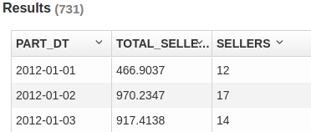
PowerBi, Requires:
- Net 4.5 or later Download

- SP1 of Windows 7 (Be carefull with this point, because there isn’t a especific warning msg)
Second, Install Tableau Desktop 9.3.3 On windows

Used Software
- Kylin: 1.5.2
- Kylin ODBC 1.5
- Power BI

Create ODBC Connection
- Install Kylin ODBC
- Add DNS System in Windows

- And configure: User-name /Password: ADMIN / KYLIN
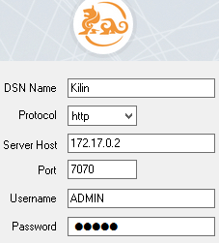
- Click Connect and Choose the project

- Click on “Done”

Create Connection in PowerBI
 > > > 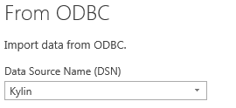

We will use de default login / password:
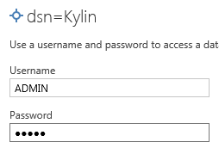
We can see exist tables:
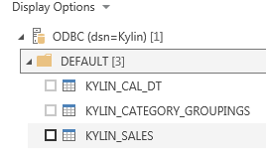

Error: Too small for an Int32


For any suggestions, feel free to contact me
Thanks, Alberto

